./

Report-Chat with Jarvis

Course Code: <CODE>



Version Number:

Team Members :

Team No:

Module: Model Based System Engineering

|  |  |  |  |  |  |
| --- | --- | --- | --- | --- | --- |
| **Ver. Rel. No.** | **Release Date** | **Prepared. By** | **Reviewed By** | **Approved By** | **Remarks/Revision Details** |
| 1 | 10/10/20 | SANTHRUPTHI.K |  |  |  |
|  |  |  |  |  |  |
|  |  |  |  |  |  |
|  |  |  |  |  |  |
|  |  |  |  |  |  |

**Document History**

# 

**TABLE OF CONTENTS**

|  |  |  |
| --- | --- | --- |
| Sl. No. | Contents | Page No. |
| 1 | Introduction | 3 |
| 2 | Aim and Objective | 4 |
| 3 | Requirements | 5 |
| 4 | Design | 6-7 |
| 5 | Test Cases | 8 |
| 6 | Expected Result | 9 |
| 7 | Conclusion | 10 |

**INTRODUCTION**

**1.1 PROBLEM STATEMENT**

           When we want a simple question answered, we need to search for a

specific App and search within the App for the information we need, or browse through a set of pages through the website. A few years ago, websites, apps, and social media were the options to reach a company fast. But the response rate on these channels was too slow for our patience.To overcome this problem we use chatbots.

                   Today chatbots first welcome us on all of these channels. We interact with them as if we are talking to a person and solve our problems quickly.Chatbots save us from waiting at long queues at call centers or from searching for information across complicated web menus. Chatbots offer practical self-service options. That saves us; customers significant time and for businesses; high costs. That is why more businesses implement chatbot solutions to enhance their customers’ experience while enjoying cost savings with automation.

**1.2 DESCRIPTION**

A simple chatbot can hold a basic conversation with the clients. It includes:

1. It can tell it’s favourite song and it even ask your favourite.
2. It can say it’s favourite dialogue too.

This application can hold a good conversation with everyone.

**AIM AND OBJECTIVE**

**2.1 AIM:**

               The main aim of this project is to help to conduct an on-line chat conversation via text or text-to-speech, instead of providing direct contact with a live human agent. Designed to convincingly simulate the way a human would behave as a conversational partner.

**2.2 OBJECTIVE:**

* The objective is to help users hold a conversation.
* It is a simple bot written in C. The base algorithm is that our conversation is based on keywords. The bot seaches for this keyword and present a suitable response on basis of that keyword.

**REQUIREMENTS**

**3.1 Requirements**

* Operating system: Windows XP, 7, 8 or 10
* Editor: Code Blocks version 20.3
* Programming language: C
* Compiler: GNU GCC compiler
* Memory: 256 MB

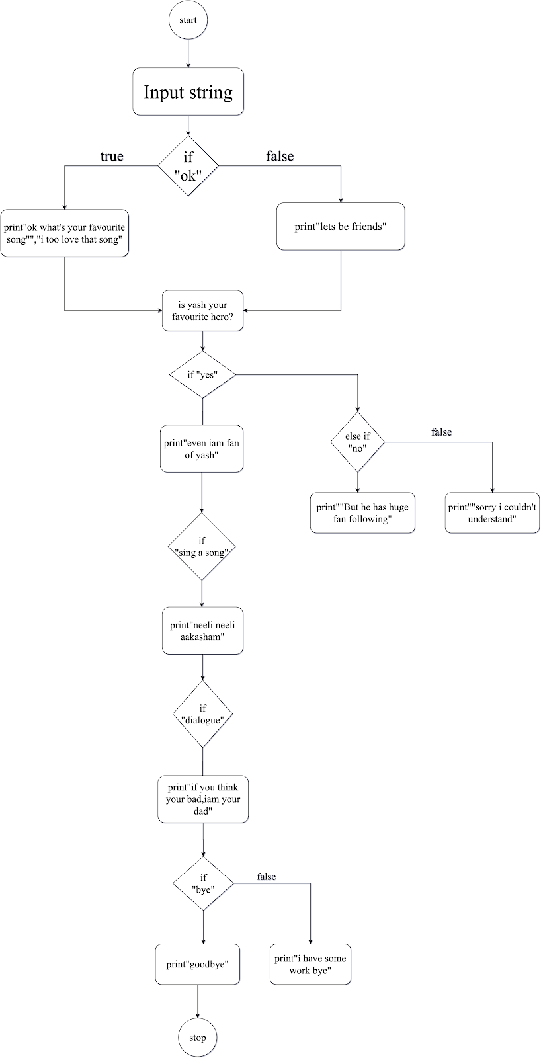

**DESIGN**

**4.1 Design Description**

  Chat with Jarvis is a simple chatbot written in C.The base algorithm is that our conversation is based on keywords. The bot seaches for this keyword and present a suitable response on basis of that keyword. It can chat with user via text message. It can reply to various texts like it can also tell its favourite song if you ask for. Even you can know it’s favourite dialogue from a movie.Bot also asks your interests.

 If the bot doesn’t understand the queries of the user it simply displays a message as “ sorry i couldn’t understand ”. The bot compares the input given by the user with the keywords that exists in code memory. If the keyword given by the user doesn’t exist in its memory it simply displays a default message.Therefore it’s working is quite simple.

**5. TEST CASES**

|  |  |  |  |
| --- | --- | --- | --- |
| **Test**  **Cases** | **Test**  **Scenario** | **Steps** | **Output** |
| **01** | Check for    Keyword “ok” | Print “ok , what’s  Your fav song”  Print “ i too love that song” | Print “ok , what’s  Your fav song”  Print “ i too love that song” |
| **02** | Check for         keyword “yes” | Print “i’m also big fan of yash” | Print “i’m also big fan of yash” |
| **03** | Check for keyword  “no” | Print “but he has big fan following” | Print “but he has big fan following” |
| **04** | Check for keyword “say a dialogue” | Print “If ur bad i’m ur dad” | Print “If ur bad i’m ur dad” |
| **05** | Check for keyword “sing a song” | Print “ neeli neeli aakasham” | Print “ neeli neeli aakasham” |
| **06** | Check for keyword “bye” | Print “goodbye” | Print “goodbye” |

**EXPECTED OUTPUT**

Chat with Jarvis - A simple chatbot is expected to hold basic conversations with the user. It could communicate the same way humans do. Bot is a computer program if provided with some inputs in Natural Language responds with something meaningful in that same language.

**CONCLUSION**

Chat with Jarvis - A simple chatbot can hold user conversations . It is keyword based. It compares the user text with the keyword stored in the memory. If the keyword doesn’t exist in the code memory of user it displays a default message.

The chatbot can perform many functions like it can also function as an analyst , it can also speak  but this can achieved with the knowledge in artificial intelligence.